***Sports Stars***

***The selects three pairs. The pairs made to teacher***

***stand facing each other. The teacher whispers a game to each pair.***

|  |
| --- |
| **Student marks** |

|  |  |  |  |  |  |
| --- | --- | --- | --- | --- | --- |
| ***Name*** | ***Tamil*** | ***English*** | ***Maths*** | ***Science*** | ***Social*** |
| ***Madhav*** | ***50*** | ***40*** | ***60*** | ***70*** | ***80*** |
| ***Mari*** | ***60*** | ***70*** | ***80*** | ***90*** | ***20*** |
| ***Rakshan*** | ***40*** | ***50*** | ***60*** | ***80*** | ***60*** |
| ***Kabilan*** | ***25*** | ***26*** | ***27*** | ***60*** | ***17*** |
| ***Kishor*** | ***26*** | ***27*** | ***28*** | ***29*** | ***13*** |

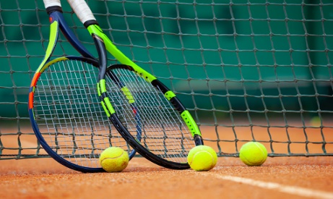

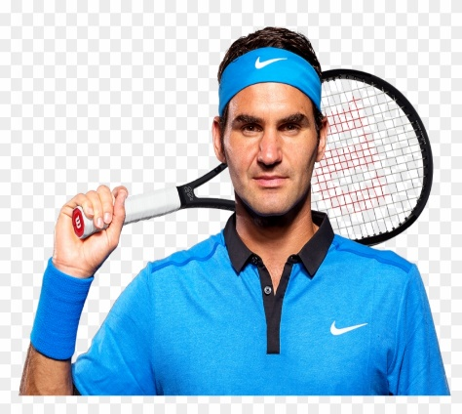***[](https://www.youtube.com/embed/ZSBLg2qWS-k?feature=oembed)***